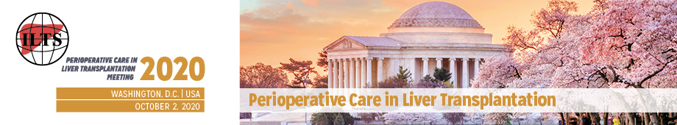
ILTS Perioperative Care in Liver Transplantation
La Maison Francaise
Embassy of France
4101 Reservoir Road NW
Washington, DC, 20007, USA

October 2, 2020

EDUCATIONAL CASE SUBMISSION

Presenter:
Name, Title:

Affiliation:

E-mail Address:

Case submission:
Title
Enter your title here

Learning Objectives (50 words)
Enter your learning objectives here

Brief Description (300 words)
Enter your description here

