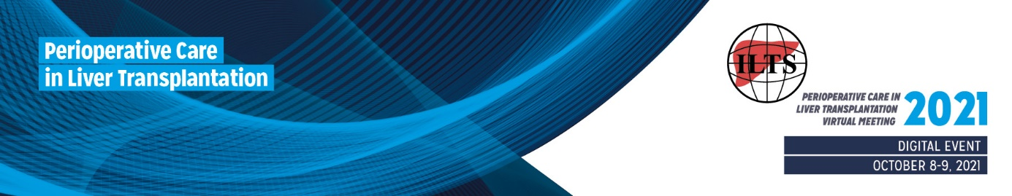
ILTS Perioperative Care in Liver Transplantation Virtual Meeting
Digital Event

October 8-9, 2021

EDUCATIONAL CASE SUBMISSION

Presenter:
Name, Title:

Affiliation:

E-mail Address:

Case submission:
Title
Enter your title here

Learning Objectives (50 words)
Enter your learning objectives here

Brief Description (300 words)
Enter your description here

